UNIFOR LABOUR DAY 2019 – ATHLETIC JACKETS ORDER FORM
ORDER DEADLINE: JUNE 14, 2019 | ORDER DATE

BILLING ADDRESS |  |  |  | SHIPPING ADDRESS (if different than billing address)
Local #
Contact
Address
City |  | Postal Code |  |  |  | Postal Code
Phone |  | Fax |  |  |  | Fax
Email (billing) |  |  |  | Email (order)
 |  |  |  | Check here if the above is a RESIDENTIAL address:

JACKET SIZES |  |  |  |  |  |  |  |  |  |  |  | TOTAL | PRICE FOR ALL ATHLETIC JACKETS: $45.00  Orders up to 100 units/local are subsidized $15.00/ea.  Shipping charges & HST are extra.  ALL ORDERS WILL BE DELIVERED BY AUGUST 19.
 | XS |  | S |  | M | L |  | XL | 2XL | 3XL | 4XL
UNISEX
 |  |  |  |  |  |  | TOTAL # OF ATHLETIC JACKETS ORDERED
***MINIMUM ORDER QUANTITY OF 12 REQUIRED*** Orders under 12pcs will not be customized with the local number.

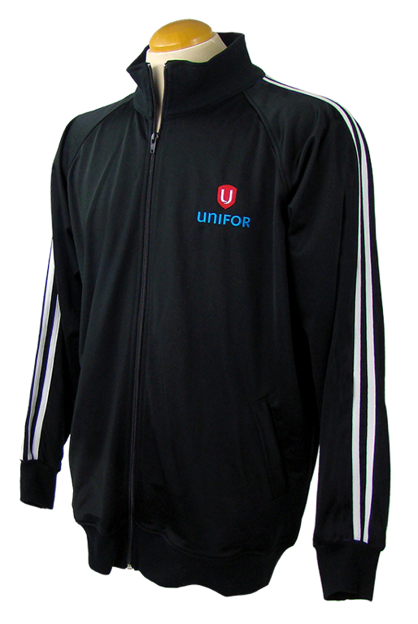
LOCAL NUMBER
TO BE EMBROIDERED ON THE LEFT CHEST
BELOW THE UNIFOR LOGO

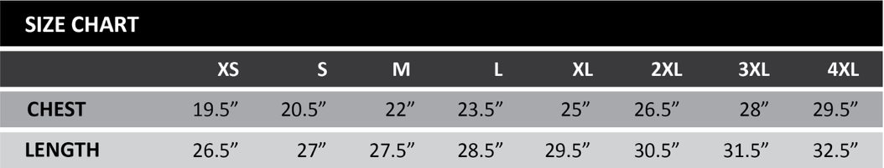

SEND YOUR ORDER BY JUNE 14

FAX THIS FORM TO 450 449-4668 OR

EMAIL TO PROMO@UNIVERSALPROMOTIONS.COM
QUESTIONS?
Contact us: 1 888 468-1212 | promo@universalpromotions.com
universalpromotions.com

